

**AMERICAN INTERNATIONAL UNIVERSITY-BANGLADESH**

**Laboratory Report Cover Sheet**

Title: Study of Digital to Digital Conversion (Line Coding) Using MATLAB

Experiment Number: 04 Course Title: Data Communication

Course Code: COE3103 Course Instructor: Nowshin Alam

Semester: Spring 2023-2024 Section: E Date of Submission: 19-03-2024

**Declaration and Statement of Authorship:**

1. I/we hold a copy of this report, which can be produced if the original is lost/damaged.
2. This report is my/our original work and no part of it has been copied from any other student’s work or from any other source exceptwhere due acknowledgement is made.
3. No part of this report has been written for me/us by any other person except where such collaboration has been authorized by theconcerned teacher and is clearly acknowledged in the report.
4. I/we have not previously submitted or currently submitting this work for any other course/unit.
5. This work may be reproduced, communicated, compared and archived for the purpose of detecting plagiarism.
6. I/we give permission for a copy of my/our marked work to be retained by the faculty for review and comparison, including review byexternal examiners.

**I/we understand that.**

1. Plagiarism is the presentation of the work, idea or creation of another person as though it is your own. It is a form of cheating and is avery serious academic offence that may lead to expulsion from the University. Plagiarized material can be drawn from, and presented in, written, graphic and visual form, including electronic data, and oral presentations. Plagiarism occurs when the origin of them arterial used is not appropriately cited.
2. I/we also understand that enabling plagiarism is the act of assisting or allowing another person to plagiarize or to copy my/our work.

Group no: 06  Submitted by: Abir Bokhtiar ID: 22-47038-1



**No Name ID Program Signature**

|  |  |  |  |
| --- | --- | --- | --- |
| 1 | Maeed Ahammed | 22-46280-1 | CSE |
| 2 | Riad Al Hasan | 22-46732-1 | CSE |
| 3 | Assadulla Ill Galib | 20-42434-1 | CSE |
| 4 | Sharanya Das | 19-41299-3 | CSE |

|  |  |  |
| --- | --- | --- |
| ***Faculty use only*** | | |
| *Faculty Comments* | **Marks Obtained** |  |
|  |
|  |
|  | **Total Marks** |  |
|  |
|  |  |  |

|  |  |  |  |  |  |
| --- | --- | --- | --- | --- | --- |
| Category | Proficient  [6] | Good  [5-4] | Acceptable  [3-2] | Unacceptable [1] | Secured Marks |
| **Introduction and/or Theory** | * Explains all necessary and relevant theoretical background information, measures, and variables. | * Explains the important parts of theoretical background information, may be partially irrelevant or need more details. | * Explains some theoretical background information, but some information may be missing, irrelevant or inaccurate. | * A lot of information is missing, out of context and/or inaccurate. |  |
| **Experimental procedure/Code** | * Working procedure or code is clearly presented and is supported by proper comments. * Simulation program file is provided which runs properly and shows the expected result. * Methods are clearly written, including all steps in sufficient detail for the experiment to be repeated. | * Working procedure or code is given for the experiment to be sufficient. * Simulation program file is provided which runs properly but the output does not perfectly align with expected result. * Methods are correct but the steps may be lacking in detail, making the experiment hard to be repeated. | * Working procedure or code is missing some steps and/or contains some mistakes. * Simulation program file is provided which runs properly but the output has many problems. | * Working procedure or code is absent or missing major steps and/or contains mistakes. * Simulation program file is not provided/is completely wrong. |  |
| **Block Diagrams and Graphical Results** | * Clear, accurate diagrams and graphs are labeled neatly and accurately with excellent detail. * Simulated result meets all criteria; outcomes are described clearly and accurately. | * Diagrams and plots are included and are correctly labeled in brief, but there may be some lack of clarity. * Most criteria are met, but there may be some lack of clarity and/or incorrect information. | * Diagrams and plots are included and are labeled, minor mistakes may be present. * Results do not match exactly with the theoretical values and/or analysis is unclear. | * Needed plots/ diagrams are missing or are missing important labels. * Experimental results are missing or completely incorrect. |  |
| **Data Interpretation and**  **analysis** | * Interpretation and analysis of related outcomes (consequences and implications) are logical and reflect student’s informed evaluation and ability to place evidence. * Any report questions are properly answered with detailed justification or calculations. | * Analysis is logically tied to information (because information is chosen to fit the desired conclusion); some related outcomes are not clear. * Report questions are answered correctly but may be lacking detail or contain minor logical error. | * Analysis is inconsistently tied to some of the information discussed; related outcomes (consequences and implications) are oversimplified. * Report questions are answered but contain wrong information or major logical error. | * Only the data was reported, there is no analysis. * Report questions are missing or are completely wrong. |  |
| **Overall writing quality** | * Demonstrates thorough and sophisticated understanding. Conclusions drawn are appropriate for analyses; * Writing is strong and easy to understand; ideas are fully elaborated and connected; effective transitions between sentences; no typographic, spelling, or grammatical errors. | * Hypotheses are clearly stated, but some concluding statements not supported by data or data not well integrated. * Writing is clear and ideas are connected; effective transitions between sentences; minor typographic, spelling, or grammatical errors. | * Some hypotheses missing or misstated; conclusions not supported by data. * Writing lacks clarity, noticeable amount of typographic, spelling, or grammatical errors are present. | * Conclusions do not match hypotheses, not supported by data; no integration of data from different sources. * Very unclear language, many grammatical and spelling errors. |  |
| Comments: |  | | | Total Marks  (Out of 30): |  |

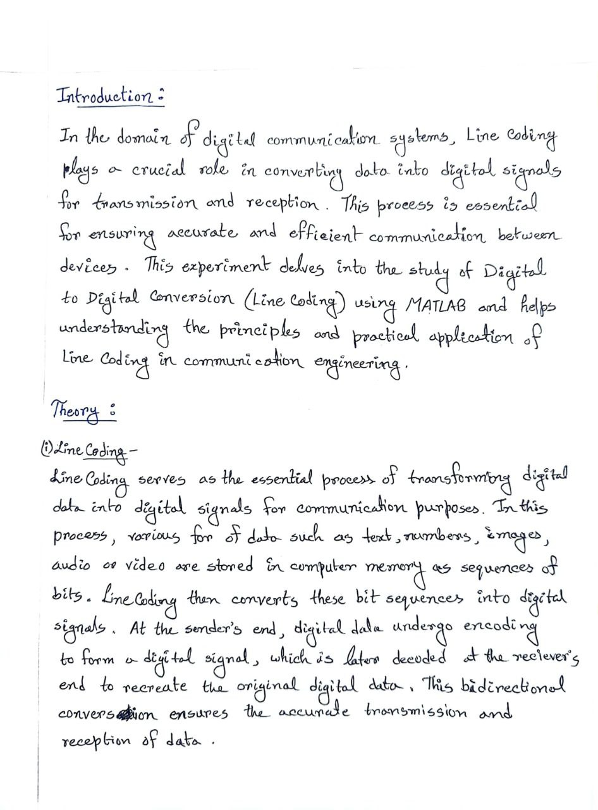

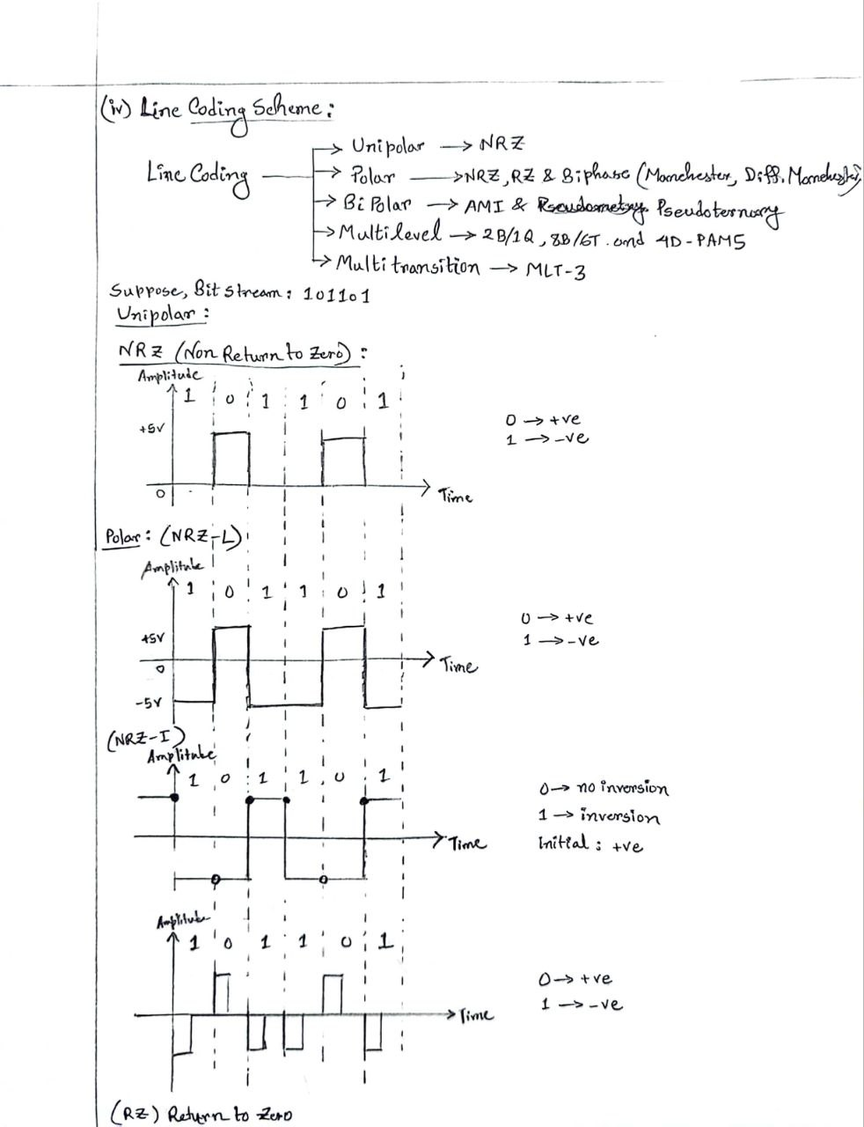

## Simulated Results:

ID: AB-CDEFG-H  
ID: 22-47038-1

(Task 1) Polar NRZ-L assuming bit rate is 4 kbps.

Code-

% polar NRZ-L

% 22-47038-1

% AB-CDEFG-H

clc

clear all

close all

bit_stream = [0 0 0 0 0 0 1 1 1 0 0 0];

no_bits = length(bit_stream);

bit_rate = 4000; % 4 kbps

pulse_per_bit = 1; % for polar NRZ-L

pulse_duration = 1/((pulse_per_bit)*(bit_rate));

no_pulses = no_bits*pulse_per_bit;

samples_per_pulse = 500;

fs = (samples_per_pulse)/(pulse_duration); %sampling frequency

% including pulse duration in sampling frequency

% ensures having enough samples in each pulse

t = 0:1/fs:(no_pulses)*(pulse_duration); % sampling interval

% total duration = (no_pulse)*(pulse_duration)

no_samples = length(t); % total number of samples

dig_sig = zeros(1,no_samples);

max_voltage = 5;

min_voltage = -5;

for i = 1:no_bits

if bit_stream(i) == 0

dig_sig(((i-1)*(samples_per_pulse)+1):i*(samples_per_pulse)) = max_voltage*ones(1,samples_per_pulse);

else

dig_sig(((i-1)*(samples_per_pulse)+1):i*(samples_per_pulse)) = min_voltage*ones(1,samples_per_pulse);

end

end

plot(t,dig_sig,'linewidth',1.5)

grid on

xlabel('time in seconds')

ylabel('Voltage')

ylim([(min_voltage - (max_voltage)*0.2)

(max_voltage+max_voltage*0.2)])

title(['NRZ - L for ',num2str(bit_stream),''])

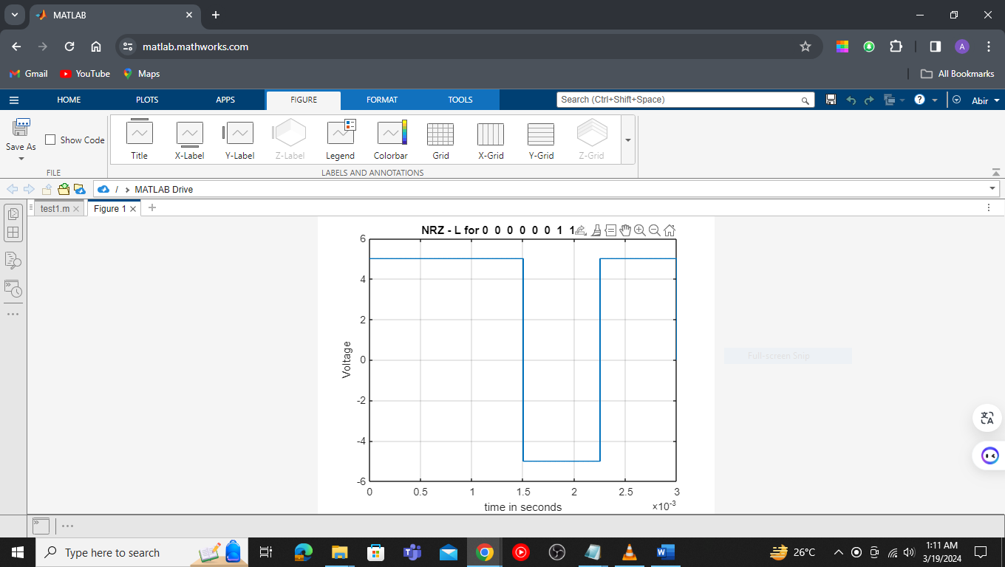

Figure 1- NRZ-L for Bit stream: 0 0 0 0 0 0 1 1 1 0 0 0

(Task 2) Manchester assuming bit rate is 2 kbps.

Code –

% Manchester

% 22-47038-1

% AB-CDEFG-H

clc

clear all

close all

bit_stream = [0 0 0 0 0 0 1 1 1 0 0 0];

no_bits = length(bit_stream);

bit_rate = 2000; % 2 kbps

pulse_per_bit = 2; % for Manchester

pulse_duration = 1/((pulse_per_bit)*(bit_rate));

no_pulses = no_bits*pulse_per_bit;

samples_per_pulse = 500;

fs = (samples_per_pulse)/(pulse_duration); %sampling frequency

% including pulse duration in sampling frequency

% ensures having enough samples in each pulse

t = 0:1/fs:(no_pulses)*(pulse_duration); % sampling interval

% total duration = (no_pulse)*(pulse_duration)

no_samples = length(t); % total number of samples

dig_sig = zeros(1,no_samples);

max_voltage = 5;

min_voltage = -5;

for i = 1:no_bits

j = (i-1)*2;

if bit_stream(i) == 1

dig_sig((j*(samples_per_pulse)+1):(j+1)*(samples_per_pulse)) = min_voltage*ones(1,samples_per_pulse);

dig_sig(((j+1)*(samples_per_pulse)+1):(j+2)*(samples_per_pulse)) = max_voltage*ones(1,samples_per_pulse);

else

dig_sig((j*(samples_per_pulse)+1):(j+1)*(samples_per_pulse)) = max_voltage*ones(1,samples_per_pulse);

dig_sig(((j+1)*(samples_per_pulse)+1):(j+2)*(samples_per_pulse)) = min_voltage*ones(1,samples_per_pulse);

end

end

plot(t,dig_sig,'linewidth',1.5)

grid on

xlabel('time in seconds')

ylabel('Voltage')

ylim([(min_voltage - (max_voltage)*0.2)

(max_voltage+max_voltage*0.2)])

title(['Manchester for ',num2str(bit_stream),''])

Figure 2- Manchester for Bit stream: 0 0 0 0 0 0 1 1 1 0 0 0

(Task 3) AMI assuming bit rate is 5 kbps

Code –

% AMI

% 22-47038-1

% AB-CDEFG-H

clc

clear all

close all

bit_stream = [0 0 0 0 0 0 1 1 1 0 0 0];

no_bits = length(bit_stream);

bit_rate = 5000; % 5 kbps

pulse_per_bit = 1; % for AMI

pulse_duration = 1/((pulse_per_bit)*(bit_rate));

no_pulses = no_bits*pulse_per_bit;

samples_per_pulse = 500;

fs = (samples_per_pulse)/(pulse_duration); %sampling frequency

% including pulse duration in sampling frequency

% ensures having enough samples in each pulse

t = 0:1/fs:(no_pulses)*(pulse_duration); % sampling interval

% total duration = (no_pulse)*(pulse_duration)

no_samples = length(t); % total number of samples

dig_sig = zeros(1,no_samples);

max_voltage = 5;

min_voltage = 0;

sign = 1;

for i = 1:no_bits

if bit_stream(i) == 1

dig_sig(((i-1)*(samples_per_pulse)+1):i*(samples_per_pulse)) = sign*max_voltage*ones(1,samples_per_pulse);

sign = (-1)*sign;

else

dig_sig(((i-1)*(samples_per_pulse)+1):i*(samples_per_pulse)) = min_voltage*ones(1,samples_per_pulse);

end

end

plot(t,dig_sig,'linewidth',1.5)

grid on

xlabel('time in seconds')

ylabel('Voltage')

title(['AMI for ',num2str(bit_stream),''])

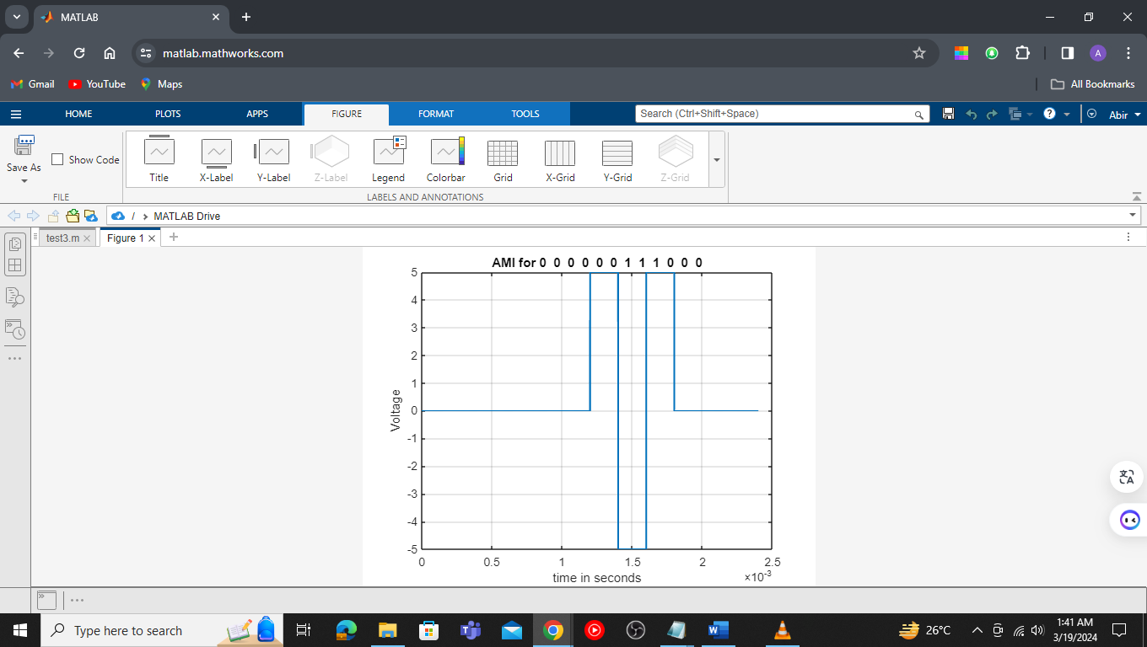

Figure 3- AMI for Bit stream: 0 0 0 0 0 0 1 1 1 0 0 0

